# Name: GAELA, PRINCESS MAE G.

Section: C1-2BSIT-02 Schedule:

Class number: Date:

## Lesson title: Fitness Self-Assessment Lesson Objectives:

At the end of the lesson, the students should be able to:

1. Administer a Fitness Self-Assessment;
2. Identify exercises use to assess fitness.

## Materials:

Activity Sheet, watch that measures second/ stopwatch, measuring tape, meter stick/ruler, weighing scale

**References:** https://[www.mayoclinic.org/healthy-](http://www.mayoclinic.org/healthy-) lifestyle/fitness/in-depth/fitness/art- 20046433,https://www.womenshea lthmag.com/fitness/a19912777/self

-assessment/,

**Productivity Tip:**

Set fitness goals at the beginning of the semester. It’s better to start with easy exercise goals As you meet them, you’ll build self-confidence and momentum. Then you can move on to more challenging goals. SMART goal setting is one of the most effective time management strategies that can be used in just about any aspect of life, including your post-college career. SMART is an acronym that stands for the following: S – Specific, M – Measurable, A – Achievable, R – Relevant, T – Time Bound.

## LESSON PREVIEW/REVIEW Introduction (2 mins)

Welcome to PED 028: Fitness Exercises Towards Health and Fitness 2! In this course, you will learn more about fitness and recreational activities! Your primary outputs include recreational activities and fitness portfolio.

## Activity 1: What I Know Chart, part 1 (3 mins)

There are 3 questions on the second column about the topic for the day and base on the questions, write in the first column what you know. Leave the third column for a while.

|  |  |  |
| --- | --- | --- |
| **What I Know** | **Questions** | **What I Learned (Activity 4)** |
| It is monitoring your health | 1. What is Fitness Self- Assessment? | Fitness Self-Assessment is to assess overall physical fitness levels by conducting cardiovascular, muscular endurance and flexibility tests.This is a tool to help you track your fitness levels and make fitness improvements or maintain your current fitness level before testing again. |
| Exercise and monitoring your BMI | 2. How will you assess your fitness level? | You can lift a heavier weight for the same amount of reps.  You have more energy.  Your jeans fit better.  You don't crave unhealthy foods as much.  You're taking shorter rest periods.  You look forward to your workouts. |
| PUSH UP AND SIT AND REACH | 3. What are the exercises to be use to administering Fitness Self- Assessment? | 1. Resting heart rate – to assess aerobic fitness. 2. Push-ups – to assess upper-body muscular endurance. 3. Head turning – to assess neck flexibility. 4. 12-minute walk/run – to assess cardio capacity. 5. Plank – to assess core stability. 6. Loop-the-loop – to assess shoulder mobility. 7. Vertical jump – to assess explosive power. |

# Name: GAELA, PRINCESS MAE G

Section: C1-2BSIT-02 Schedule:

Class number: Date:

=

1. **MAIN LESSON**

**Activity 2: Content Notes (13 mins) Fitness Self-Assessment**

The purpose of the Fitness Self-Assessment is to assess overall physical fitness levels by conducting

cardiovascular, muscular endurance and flexibility tests. It is important to remember that you do not need to score in the excellent category on every test. This is a tool to help you track your fitness levels and make fitness improvements or maintain your current fitness level before testing again.

In doing a fitness self-assessment not so much to score high, but rather to record where our how strong and flexible we are now, so that we can compare how strong and flexible we will be at the end of this course.

Record your performance in the tracking sheet found on the last pages of this Student Activity Sheet (SAS). **Important:** Keep this SAS safe. You will need to submit all the numbers you record in this sheet throughout the semester.

## Cardio: Resting Heart Rate

Your heart rate at rest is a measure of heart health and fitness. For most adults (18 years old +), a healthy heart rate is 60 to 100 beats a minute.

To check your pulse over your carotid artery, place your index and middle fingers on your neck to the side of your windpipe. To check your pulse at your wrist, place two

fingers between the bone and the tendon over your radial artery, located on the palm side of your wrist below the thumb.

When you feel your pulse, look at your watch and count the number of beats in 15 seconds. Multiply this number by 4 to get your heart rate per minute. Let's say you count 20 beats in 15 seconds. Multiply 20 by 4 for a total of 80 beats a minute.

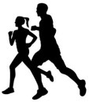 ***You will record your performance in the chart.***

* 1. **Cardio: 12-min run test**

You'll need a timer to know when 12 minutes are up. Note that some running watches and fitness monitors have a 12-minute fitness test mode. Perform a short warm-up of 10 to 15 minutes of low to moderately strenuous activity before performing any fitness testing. When you are warmed up, get going. Run or walk as far as you can in 12 minutes. Record the total number of miles or kilometers you traveled in 12 minutes.

 ***You will record your performance in the chart.***

Name: GAELA, PRINCESS MAE G

Section: C1-2BSIT-02 Schedule:

Class number: Date:

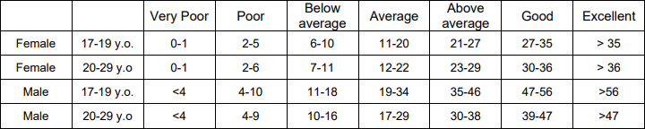

**Here are some norms to interpret the result of the test.**

|  |  |  |  |  |  |
| --- | --- | --- | --- | --- | --- |
| **Age** | **Excellent** | **Above**  **average** | **Average** | **Below**  **average** | **Poor** |
| 15-16 | >2100m | 2000-2100m | 1700-1999m | 1600-1699m | <1600m |
| 17-20 | >2300m | 2100-2300m | 1800-2099m | 1700-1799m | <1700m |
| 20-29 | >2700m | 2200-2700m | 1800-2199m | 1500-1799m | <1500m |

* 1. 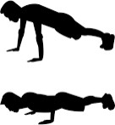**Muscular strength and endurance: Push-up test**

Count how many push-ups you can do until you need to stop for rest. If you're just starting a fitness program, do modified push-ups on your knees. If you're generally fit and able to do them, do classic push-ups.

Follow these steps for both types:

* Lie face-down on the floor with your elbows bent and your palms next to your shoulders.
* Keeping your back straight, push up with your arms until your arms are extended.
* Lower your body until your chin touches the floor.
  + ***You will record your performance in the chart.***

**Here are some norms to interpret the result of the test.**

* 1. **Muscular strength and endurance: Sit-up test**

Count how many situps you can do in one (1) minute.

* Lie on the floor with knees bent at a 90-degree angle and feet flat on the floor. A partner holds your feet firmly to the floor. Another option is to place your feet on the wall so your knees and hips are bent at a 90- degree angle. Cross your arms across your chest. This is the down position.
* To move into the up position, raise your head and shoulders off the floor. Don't lift your buttocks off the floor.
* Return to the down position.
* Each time you move to the up position is counted as one sit-up.
  + ***You will record your performance in the chart.***

Name: GAELA, PRINCESS MAE G

Section: C1-2BSIT-02 Schedule:

Class number: Date:

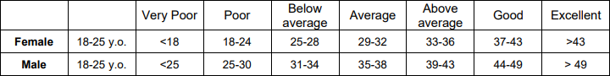**Here are some norms to interpret the result of the test.**

* 1. **Flexibility: Sit-and-reach test**

Sit and reach – record your best score. The sit-and-reach test is a simple way to measure the flexibility of the back of your legs, your hips and your lower back.

Here's how: • Place a meter stick or at least 2 rulers on the floor. Secure it by placing a piece of tape across the meter stick at the 15-inch (38-centimeter) mark.

* Place the soles of your feet even with the 15-inch (38-centimeter) mark on the yardstick. • Slowly reach forward as far as you can, exhaling as you reach and holding the position for at least 1 second.
* Note the distance you reached.
* Repeat the test two more times.
  + ***You will record your best of the three reaches in the chart***

**Here are some norms to interpret the result of the test.**

* 1. **Body composition: Body mass index**

Your body mass index (BMI) is a calculation that indicates whether you have a healthy amount of body fat. An increase in BMI usually means an increase in fat. Your BMI will help determine the weight you’re supposed to be in. You can determine your BMI with a BMI table or online calculator, or do the math yourself:

**Step 1**: Multiply your height in inches times your height in inches.

**Step 2:** Divide your weight by the number you arrived at in Step 1.

**Step 3**: Multiply the number you came up with in Step 2 by 705. The result is your BMI.

(Credit: “simple calculator,” © 2010 , [www.learningDSLRVideo.com](http://www.learningDSLRVideo.com/) used under a Creative Commons Attribution 2.0 Generic license: <http://creativecommons.org/licenses/by/2.0/legalcode>)

 ***Record your hip and waist measurements in the chart.***

**Here are some norms to interpret the result of the test.**

Some norms:

BMI of 19 or below: underweight

BMI between 19 and 24.9: healthy range

# Name: GAELA, PRINCESS MAE G

Section: C1-2BSIT-02 Schedule:

Class number: Date:

BMI between 25 and 29.9: overweight BMI of 30 or greater: obese

Name: GAELA, PRINCESS MAE G

Section: C1-2BSIT-02 Schedule:

## Activity 3: Skill-building Activities: My Fitness Self-Assessment

Class number: Date:

**Direction:** Fill-up the chart by doing the exercises above. Remember to keep this information safe. Make a copy just to be sure. You will record your performance at every grading period

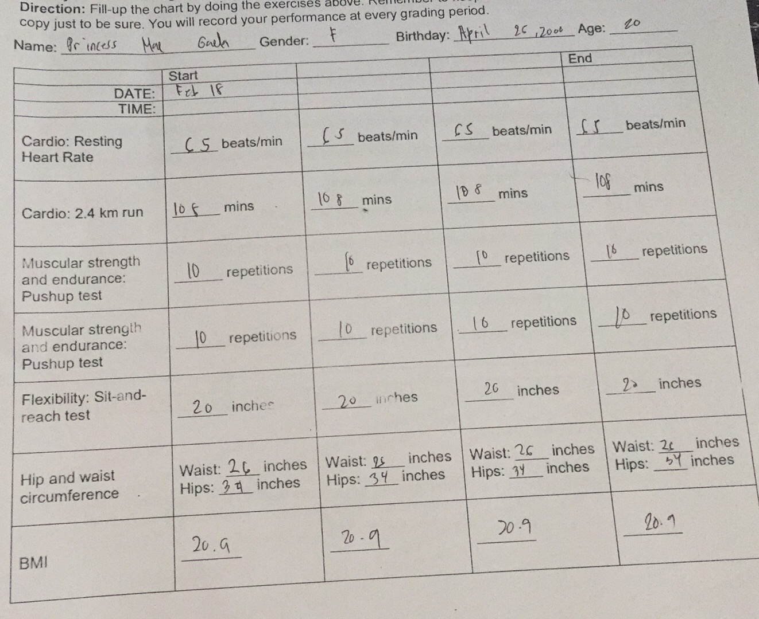

# Name: GAELA, PRINCESS MAE G

Section: C1-2BSIT-02 Schedule:

## Activity 4: What I Know Chart, part 2 (2 min)

Class number: Date:

In this activity, you need to go back to Activity 1. In the What I Know Chart, write your answers in column 3 based on the content notes.

BODY MASS INDEX

## Activity 5: Check for Understanding (5 mins)

**Identification:** Read each item carefully and identify what is asked. Write your answer on the space provided before the number.

___________1. It is a calculation that indicates whether you have a healthy amount of body fat.

___________2. It is a simple way to measure the flexibility of the back of your legs, your hips and your lower back.

SIT-AND-REACH

FITNESS SELF- ASSESSMENT

___________3. It is a tool to help you track your fitness level.

___________4. Classification of a person with a Body mass index of 19.

UNDERWEIGHT

PUSH UP AND SIT UP

___________5. It is an exercise use to assess muscular strength and endurance.

**WRAP-UP**

**Activity 6: Thinking about Learning (5 mins)**

* + 1. **Work Tracker**

You are done with this session! Let’s track your progress. Shade the session number you just completed.

## Think about your Learning

My Learning Tracker

|  |  |  |
| --- | --- | --- |
| What is the date today? | What module/ lesson have you  accomplished? What are the activities you’ve done? | What are the things you have learned in today’s session? |
| FEBRUARY 18, 2021 | ACTIVITY 1 AND 2, About fitness | I learned to compute BMI |

# Name: GAELA, PRINCESS MAE G

Section: C1-2BSIT-02 Schedule:

Class number: Date:

## FAQs:

Read some of the answers to these Frequently Asked Questions to add to your knowledge about today’s topic:

**Q:** Who is considered a fit person?

**A:** Being fit is not all about how you look. A person who is physically fit is capable of performing and enjoying daily activities. A person who is fit is capable of living life to its fullest.

**Q:** What is the proper way to breathe during exercise?

**A:** You should never hold your breath when doing exercise. Often, you breathe in during the prep phase, and breathe out during effort**.** For example, when doing squats, breathe in as you bend your knees and go down, and breathe out when you straighten your legs to come back up. There is one exception to this rule: for exercises that require effort as you expand your chest (such as horizontal pulls), you should breathe in during the effort.

## KEY TO CORRECTIONS

|  |
| --- |
| Activity 5 -Check for Understanding |
| 1. BMI/Body Mass Index |
| 2. Sit and Reach |
| 3. Fitness Self-Assessment |
| 4. Underweight |
| 5. Push-ups, Sit-ups |

LESSON 1: ORIENTATION PED 028

# Name: GAELA, PRINCESS MAE G

# Section: C1-2BSIT-02 Schedule:

Class number: Date:

ACTIVITY 1: WHAT I KNOW CHART

1.)Give three social media etiquettes.

* Don't be overly promotional. Try not to message all your customers asking them to buy your products and avoid sharing constant advertisements on your page
* Avoid over-automation
* Handle your hashtags carefully

2.) Why observing social media etiquette important?

* It is important because you can protect yourself through this especially on your personal life.

3.) Write some tips on how to avoid exercise related injuries?

Take time off.

Wear the right gear.

Strengthen muscles.

Increase flexibility.

Use the proper technique.

Take breaks.

Play safe.

**ACTIVITY 2:CONTENT NOTES**

ACTIVITY 3: SKILL-BUILDING ACTIVITIES

1.)I WANT TO ADD THE FOLLOWING GUIDELINES AND SOCIAL MEDIA ETIQUETTES. .

THE FOLLOWING ARE MY REASONS WHY I WANT TO ADD SUCH GUIDELINES/ETIQUETTES.

I want to add the ff. guidelines The ff. reasons why I want to add such GUIDELINES/ETIQUETTES

And social media etiquettes.

1.Listening To be able to understand content

2. Understand the content To be able to be more knowledgeable

3.Use Good words To not hurt others

2.) I want to add the ff. Safety tips The ff. reasons why I want to add such safety tips in the list.

1.Love your Body Do not be insecure to others

2. Know your limits To be able to help yourself no to be injured

3. Check your body goals To be motivated

ACTIVITY 4: WHAT I KNOW

1.) Give three social media etiquettes.

• Don’t be overly promotional. Try not to message all your customers asking them to buy your products and avoid sharing constant advertisements on your page

• Avoid over-automation

• Handle your hashtags carefully

2.) Why observing social media etiquette important?

• It is important because you can protect yourself through this especially on your personal life.

3.) Write some tips on how to avoid exercise related injuries?

Take time off.

Wear the right gear.

Strengthen muscles.

Increase flexibility.

Use the proper technique.

Take breaks.

Play safe.

ACTIVITY 5:CHECK FOR UNDERSTANDING

I HAVE 10 REASONS WHY I’M READY FOR PED 028

* 1. Im ready to be fit
  2. Im ready because I want to be healthy
  3. Im ready because I have my body goals
  4. Im ready because I want to lose weight
  5. Im ready to learned
  6. Im ready because I really want to improve my self
  7. Im ready because im motivated
  8. Im ready because I want to know my limits
  9. Im ready because I want to be more athletic
  10. Im ready because I wanted to have long life

ACTIVITY 6: THINKING ABOUT LEARNING A). PROGRESS TRACKER

PERIOD 1: 1

B) ESSAY:

By simply listening in all he teaches us and doing all the task.

Being more attentive to class and being a good example to other students. I will help my classmates on coping up with some activities they have questions.